Digital Egypt Pioneers Initiative رواد مصر الرقمية
Round 4 الدورة الرابعة
2025 - 2026 2025 - 2026

Track: AI & Data Science - Microsoft Machine Learning Engineer
Group Code: ONL4_AIS2_S7
Instructor: Eman Elgalad
Company Name: Skills Dynamix



Project Name

"AI-Powered Predictive Maintenance for Industrial Equipment"
No. | Name
1 | Moaz Osama Esamil Hataba (TL)
2 | Abrar Ashraf Shaban Ahmad
3 | Marwan Muhammad Darwish Ammar
4 | Yussef Ahmad Muhammad Elshamy
5 | Salma Muhammad Nageh Abdul-Hamid
6 | Nour-Eldin Kamel Muhammad Hasanein

Task |  | Page No. | Evaluation
System Actors & Interactions |  | 5
Use Cases |  | 7
Use Case Diagram |  | 10
Functional Requirements |  | 11
Non-Functional Requirements |  | 13
System Capabilities |  | 15
System Constraints |  | 16
Architecture Style |  | 17
High-Level System Components |  | 18
System Interactions |  | 20
Software Architecture |  | 21

System Analysis
&
Design
System Actors & Interactions:
- Maintenance Engineers
  - Role:
    - Maintenance engineers are the primary users of the predictive maintenance system. They are responsible for monitoring equipment health, scheduling maintenance activities, and minimizing unexpected failures.
  - Responsibilities:
    - Monitor equipment health status.
    - Analyze Remaining Useful Life (RUL) predictions.
    - Schedule maintenance operations.
    - Monitor equipment degradation through simulated real-time monitoring.
  - Needs:
    - Accurate Remaining Useful Life predictions.
    - Real-time monitoring dashboard.
    - Explainable prediction results.
    - Maintenance recommendations.
    - Automatic real-time equipment monitoring.
    - Continuous Remaining Useful Life updates.
  - Priority:
    - High.
- Plant Managers
  - Role:
    - Plant managers oversee operational performance and maintenance planning to ensure efficient production and minimal downtime.
  - Responsibilities:
    - Monitor operational performance.
    - Approve maintenance schedules.
    - Evaluate maintenance costs.
    - Improve operational efficiency.
  - Needs:
    - Equipment health reports.
    - Downtime statistics.
    - Performance metrics.
    - Maintenance planning support.
    - Operational dashboards for decision support.
  - Priority:
    - High.
- System Administrators
  - Role:
    - System administrators are responsible for deploying, maintaining, and monitoring the predictive maintenance platform.
  - Responsibilities:
    - Deploy backend services.
    - Monitor API availability.
    - Ensure system reliability.
    - Monitor application logs.
  - Needs:
    - Stable deployment.
    - Secure APIs.
    - Reliable performance.
    - Error monitoring.
  - Priority:
    - Medium.
- Machine Learning Engineers
  - Role:
    - Machine learning engineers develop and improve machine learning models for Remaining Useful Life prediction.
  - Responsibilities:
    - Analyze data.
    - Engineer features.
    - Train machine learning models.
    - Evaluate model performance.
    - Implement Explainable AI.
    - Monitor model performance during simulated real-time prediction.
  - Needs:
    - High-quality datasets.
    - Feature importance analysis.
    - Performance metrics.
    - Model explainability.
  - Priority:
    - High.

Use Cases:
- UC-1: Dataset Selection
  - Primary Actor
    - Maintenance Engineer.
  - Preconditions
    - The NASA CMAPSS dataset is available.
    - The system is initialized.
  - Main Flow
    - User selects FD001–FD004.
    - User selects Engine ID.
    - System validates selection.
    - System validates the selected dataset and engine.
    - Selected data is prepared for simulation and prediction.
  - Output
    - Selected dataset.
- UC-2: Automatic Real-Time Monitoring
  - Primary Actor
    - Maintenance Engineer.
  - Preconditions
    - Dataset selected.
    - A trained prediction model is available.
    - Simulation started.
  - Main Flow
    - System automatically streams sensor readings.
    - Dashboard updates every cycle.
    - Backend predicts RUL continuously.
    - Equipment health status is updated.
    - Visualization refreshes automatically.
  - Output
    - Continuous equipment monitoring.
- UC-3: Predict Remaining Useful Life (RUL)
  - Primary Actor
    - Maintenance Engineer.
  - Preconditions
    - A trained machine learning model is available.
    - A NASA CMAPSS dataset scenario has been selected.
    - The backend API is running and accessible.
  - Main Flow
    - The system automatically loads the corresponding sensor data.
    - The backend preprocesses incoming data.
    - The machine learning model predicts the Remaining Useful Life (RUL).
    - The dashboard automatically displays updated predictions.
  - Output
    - Predicted Remaining Useful Life (RUL).
- UC-4: Dashboard Visualization
  - Primary Actor
    - Maintenance Engineer.
  - Preconditions
    - A prediction has been generated.
    - The dashboard is connected to the backend service.
  - Main Flow
    - Dashboard receives prediction.
    - Dashboard updates charts.
    - Dashboard updates gauges.
    - Dashboard updates health indicator.
    - Dashboard displays SHAP visualization.
  - Output
    - Updated dashboard.
- UC-5: View Historical Sensor Data
  - Primary Actor
    - Maintenance Engineer.
  - Preconditions
    - Historical sensor data is available.
  - Main Flow
    - The user selects dataset scenario.
    - The user selects engine.
    - The user selects operational cycle range.
    - The system retrieves historical sensor measurements.
    - The dashboard displays sensor trends and degradation visualizations.
  - Output
    - Historical sensor readings and trend analysis.
- UC-6: Explain Prediction
  - Primary Actor
    - Maintenance Engineer.
  - Preconditions
    - A prediction has been generated.
  - Main Flow
    - The user requests an explanation for the prediction.
    - The SHAP framework computes feature contributions.
    - The dashboard visualizes feature importance and SHAP values.
    - The dashboard highlights the most influential sensors affecting the prediction.
    - The user reviews and interprets the factors influencing the prediction.
  - Output
    - Feature importance analysis and SHAP explanations.
- UC-7: Review Maintenance Recommendation
  - Primary Actor
    - Maintenance Engineer.
  - Preconditions
    - A Remaining Useful Life (RUL) prediction has been generated.
    - Equipment health status has been evaluated.
  - Main Flow
    - User reviews RUL prediction.
    - User reviews equipment health status.
    - System provides maintenance recommendation.
    - User reviews the recommendation and decides whether maintenance actions should be initiated.
  - Output
    - Maintenance recommendation.
- UC-8: Generate Reports
  - Primary Actor
    - Plant Manager.
  - Preconditions
    - Prediction and maintenance data are available.
  - Main Flow
    - The user selects the report type.
    - The system generates the requested report.
    - The report includes prediction summaries, model performance metrics, explainability analysis, and maintenance recommendations.
  - Output
    - Maintenance and performance reports.
Use Case Diagram:

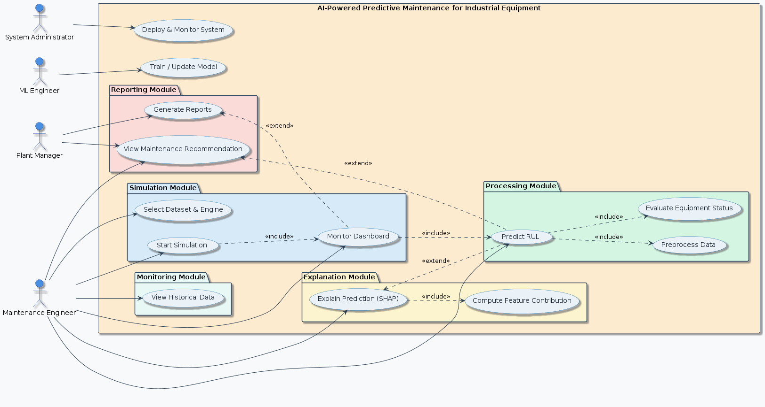
Functional Requirements:
- Dataset & Simulation
  - FR-01
    - The system shall allow users to select a NASA CMAPSS dataset scenario (FD001–FD004).
  - FR-02
    - The system shall allow users to select an engine from the selected dataset.
  - FR-03
    - The system shall automatically load and validate the corresponding sensor data before starting the simulation.
  - FR-04
    - The system shall simulate real-time sensor data streaming by sequentially replaying operational cycles from the selected NASA CMAPSS dataset.
- Prediction Engine
  - FR-05
    - The system shall preprocess incoming sensor data using the same preprocessing pipeline applied during model training.
  - FR-06
    - The system shall predict the Remaining Useful Life (RUL) using the trained machine learning model.
  - FR-07
    - The system shall continuously update the Remaining Useful Life (RUL) prediction after each simulated operational cycle.
  - FR-08
    - The system shall classify equipment health status (Healthy, Warning, or Critical) based on the predicted Remaining Useful Life (RUL).
- Explainable AI
  - FR-09
    - The system shall generate SHAP-based explanations for each prediction to identify the contribution of individual sensor features.
  - FR-10
    - The dashboard shall display SHAP values, feature importance rankings, and explanation visualizations for every prediction.

- Dashboard
  - FR-11
    - The system shall provide an interactive Streamlit dashboard for monitoring equipment health and prediction results.
  - FR-12
    - The dashboard shall automatically update sensor readings during simulation.
  - FR-13
    - The dashboard shall display (RUL, Equipment Health Status, Sensor Trends, SHAP Explanations, & Current Simulation Cycle).
- Historical Analysis
  - FR-14
    - The system shall allow users to view historical sensor data.
  - FR-15
    - The system shall visualize equipment degradation trends across operational cycles using interactive charts.
- Backend
  - FR-16
    - The backend shall expose RESTful API endpoints for prediction requests and dashboard communication.
  - FR-17
    - The backend shall send prediction results, equipment health status, and SHAP explanations to the dashboard in real time during simulation.
  - FR-18
    - The system shall load the trained machine learning model automatically when the backend service starts.
- Reports
  - FR-19
    - The system shall generate downloadable maintenance and performance reports.
  - FR-20
    - The generated reports shall include (Prediction Summary, Model Performance Metrics, SHAP Explainability Analysis, Equipment Health Status, & Maintenance Recommendation).
Non-Functional Requirements:
- Performance
  - NFR-01
    - The system shall generate Remaining Useful Life (RUL) predictions within one second after receiving valid sensor data under normal operating conditions.
  - NFR-02
    - The dashboard shall load completely within three seconds under normal operating conditions.
- Availability
  - NFR-03
    - The system shall remain available and responsive throughout each simulation session without unexpected interruptions.
- Reliability
  - NFR-04
    - The system shall produce consistent prediction results when processing identical input data and model configurations.
- Security
  - NFR-05
    - The system shall validate and sanitize all user inputs, rejecting invalid dataset selections, engine IDs, and malformed requests before processing.
- Usability
  - NFR-06
    - The system shall provide a simple and intuitive user interface.
  - NFR-07
    - Predictions, equipment health status, SHAP explanations, simulation progress, and visualizations shall be clearly displayed and easy to interpret.
- Maintainability
  - NFR-08
    - The codebase shall follow PEP8 coding standards.
  - NFR-09
    - The system shall follow a modular architecture to support maintainability and extensibility.
- Scalability
  - NFR-10
    - The system architecture shall support adding new datasets and machine learning models with minimal code modifications.
- Portability
  - NFR-11
    - The system shall be executable on Windows, Linux, and macOS environments supporting Python.
- Compatibility
  - NFR-12
    - The system shall be compatible with modern web browsers including Google Chrome, Microsoft Edge, and Mozilla Firefox.
- Explainability
  - NFR-13
    - The system shall provide clear and consistent SHAP-based explanations for every prediction.
- Documentation
  - NFR-14
    - The source code shall include clear comments, API documentation, and developer documentation to facilitate future maintenance and extension.
- Reproducibility
  - NFR-15
    - The system shall produce reproducible prediction results when executed using the same trained model, preprocessing pipeline, and input data.

System Capabilities:
- Data Simulation & Monitoring
  - The system is capable of simulating real-time sensor data by replaying CMAPSS dataset operational cycles.
  - The system can continuously monitor equipment conditions during simulation execution.
- Predictive Analytics
  - The system can estimate Remaining Useful Life (RUL) for equipment using a trained machine learning model.
  - The system can classify equipment health status into different operational states (Healthy, Warning, Critical).
- Data Visualization
  - The system provides interactive visualization of sensor readings and degradation trends.
  - The system displays real-time dashboard updates during simulation execution.
- Explainability
  - The system can generate explanations for predictions using feature contribution analysis (SHAP-based interpretation).
  - The system can highlight the most influential sensor features affecting model output.
- Reporting & Decision Support
  - The system can generate maintenance and performance reports.
  - The system supports maintenance decision-making by providing prediction insights and recommendations.

System Constraints:
- Data Constraints
  - The system is limited to the NASA CMAPSS dataset (FD001–FD004).
  - System performance depends on the quality and structure of the provided dataset.
- Model Constraints
  - Predictions are dependent on a pre-trained machine learning model.
  - Model accuracy is limited by training data quality and feature engineering.
- Architectural Constraints
  - The system relies on a REST-based backend architecture for communication.
  - The system uses a modular pipeline (preprocessing → prediction → explanation).
- Runtime Constraints
  - The system operates under simulated real-time conditions, not actual hardware sensor streams.
  - Performance depends on computational resources available on the host machine.
- Platform Constraints
  - The system is implemented in Python and must run in a Python-supported environment.
  - The system is compatible with modern web browsers for dashboard access.
- Dependency Constraints
  - The system depends on external libraries for:
    - Machine learning (e.g., scikit-learn / XGBoost).
    - Explainability (SHAP).
    - Web framework (FastAPI / Streamlit).

Architecture Style:
- The system follows a:
  - Layered Architecture (3-Tier + ML Pipeline Integration) with a modular separation of concerns:
    - Presentation Layer.
    - Application Layer (Backend Services).
    - Machine Learning & Explainability Layer.
    - Data Layer.
- This hybrid design ensures:
  - Scalability.
  - Maintainability.
  - Separation of responsibilities.
  - Easy extension for new models or datasets.

High-Level System Components:
- Presentation Layer
  - Technology:
    - Streamlit Dashboard.
  - Components:
    - Display real-time system outputs.
    - Visualize sensor data and RUL predictions.
    - Show SHAP explanations and trends.
    - Allow user interaction (dataset selection, engine selection).
- Application Layer
  - Technology:
    - FastAPI.
  - Components:
    - API Controller
      - Handles all client requests.
      - Manages communication between frontend and backend modules.
    - Simulation Engine
      - Simulates real-time behavior by replaying CMAPSS dataset cycles.
      - Controls timing and streaming of sensor data.
    - Report Generator
      - Produces downloadable reports.
      - Aggregates predictions, metrics, and explanations.
- Machine Learning & Explainability Layer
  - Components:
    - Preprocessing Pipeline
      - Cleans and transforms raw sensor data.
      - Ensures consistency with training format.
    - RUL Prediction Model
      - Predicts Remaining Useful Life for equipment.
      - Core predictive engine of the system.
    - SHAP Explainer
      - Generates feature importance values.
      - Explains model predictions for interpretability.
- Data Layer
  - Components:
    - NASA CMAPSS Dataset (FD001–FD004)
      - Source of operational sensor data.
    - Trained ML Model
      - Stored trained model used for inference.
    - Configuration Files
      - System parameters (thresholds, settings, simulation configs).

System Interactions:
- Step 1: Simulation Start
  - User selects dataset + engine.
  - Simulation Engine loads CMAPSS data.
- Step 2: Data Streaming
  - Sensor data is streamed cycle-by-cycle.
  - Sent to backend processing pipeline.
- Step 3: Processing Pipeline
  - Data is preprocessed.
  - Passed to ML model for inference.
- Step 4: Prediction Stage
  - RUL is predicted.
  - Equipment health status is determined
- Step 5: Explainability Stage
  - SHAP computes feature contributions.
  - Results sent to backend.
- Step 6: Presentation Layer
  - Dashboard updates in real time:
    - RUL.
    - Health status.
    - Sensor trends.
    - SHAP explanations.
- Step 7: Reporting
  - System generates downloadable reports on demand.

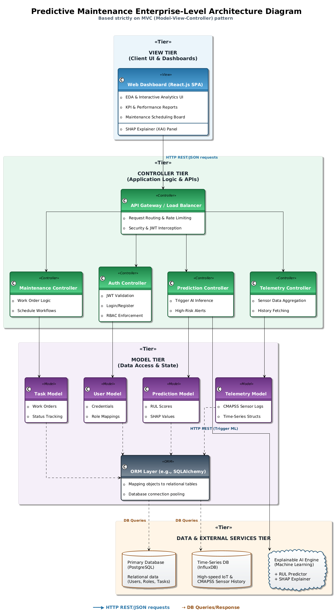
Software Architecture:

